**Artificial Intelligence and Machine Learning**

**LAB 6**

**Name: PUNEETH L**

**USN: 1BM24MC069**

6. For a dataset implement Agglomerative clustering algorithm and visualize the clusters.

Program:

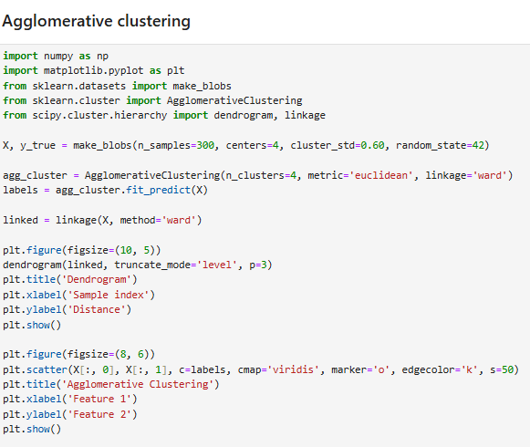

Output:

